Development Guidelines

This is not a complete guideline this will be updated every day. But you can use this as help to your developer.

- Database table names
  - Should start with prefix, sis_admin, sis_student, sis_exam, sis_timetable etc.
  - Each table should have the variables below.
    - structure_master bigint(fk) to sis_admin_structure_master table
    - active_status boolean
    - id
    - created_at
    - updated_at
    - tenant_id
    - deleted
    - Use below example.
    - <createTable tableName="sis_admin_semester">
<column autoIncrement="true" name="id" type="BIGINT">
<constraints nullable="false" primaryKey="true" primaryKeyName="pk_sis_admin_semester"/>
</column>
<column name="structure_master" type="BIGINT"/>
<column name="created_at" type="DATETIME" defaultValueComputed="CURRENT_TIMESTAMP">
<constraints nullable="false"/>
</column>
<column name="updated_at" type="DATETIME" defaultValueComputed="CURRENT_TIMESTAMP">
<constraints nullable="false"/>
</column>
<column name="created_by" type="VARCHAR(255)"/>
<column name="updated_by" type="VARCHAR(255)"/>
<column name="tenant_id" type="BIGINT"/>
<column name="deleted" type="BOOLEAN"/>
<column name="semester_code" type="VARCHAR(10)"/>
<column name="semester_name" type="VARCHAR(200)"/>
<column name="semester_name2l" type="VARCHAR(200)"/>
<column name="registered_date" type="DATE"/>
<column name="active_status" type="BOOLEAN"/>
</createTable>
  - database names like this. sis_admin_semester_word2_word3, sis_exam_grading_schema_config.
  - For foreign keys strictly follow below codes and write accordingly.
    - <changeSet id="add-structure-master-fk-for-semester-table" author="prashanthan">
<preConditions onFail="MARK_RAN" onError="MARK_RAN">
<sqlCheck expectedResult="0">SELECT COUNT(*) FROM pg_constraint WHERE conname LIKE 'fk_sis_admin_semester_on_structure_master%'</sqlCheck>
</preConditions>
<addForeignKeyConstraint baseColumnNames="structure_master" baseTableName="sis_admin_semester"
constraintName="fk_sis_admin_semester_on_structure_master" referencedColumnNames="id"
referencedTableName="sis_admin_structure_master"/>
</changeSet>
  - If you are using lists like programs, semsters, mainExams etc always use That entity itself. Never use StructureMasters of that entity.
    - Always you will have to create table using Liquibase script for adding lists like semesters, programs. Check how main exam has been done.
  - We are not limiting database columns text like VARCHAR(10), VARCHAR(20), most of the times VARCHAR(255), but need to validate from FE.
  - For descriptions and remarks we are using VARCHAR(1000).
  - Code generation should be automatic. Need to check that with PO. If that is automatic, then you need to add entry to Document code master.
  - For titles and other fields ask from PO for what are the character limit and update header Liquibase script accordingly (for title 255 characters limit in FE).
  - For RTE (Rich Text Editor data) If you don't have MEMO data type in postgresql use VARCAHR(10000) or higher based on requirement. Consider adding unlimited text limit if possible. I think need to use TEXT type for unlimited text.
  - For enums we are using VARCHAR(255)
  - For float use double precision
  - For id just copy from existing liquibase script
- Entity creation. (keep in mind for look ups, types, etc.. No need to extend from Master entity. Extend from master entity only when you will have list page in FE. If you have list page or add page user can add data then only you need to extend from Master entity)
  - Always extends from MasterEntity
    - Eg. public class Semester extends MasterEntity{

- Services Creation. (keep in mind for look ups, types, etc.. No need to extend from Master Service. Extend from master entity only when you will have list page in FE. If you have list page or add page user can add data then only you need to extend from Master Service)
  - Always extends from MasterBaseService, AuditBaseService,
    - Eg. public interface SemesterMasterService extends MasterBaseService<Semester, SemesterMasterRequestDto,
SemesterMasterResponseDto, SemesterMasterFilterDto>, AuditBaseService<Semester, SemesterMasterRequestDto,
SemesterMasterResponseDto, SemesterMasterFilterDto> {
- Requests Creation
  - public class SemesterMasterRequestDto extends BaseAssignedRequestDto
- Response Creation
  - public class SemesterMasterResponseDto extends MasterResponseDto
- Statuses Creation
  - public enum ApplicationStatus {
- Lookups creation
  - public class CourseType extends BaseLookupEntity {
- Always use Campus based filtering using Structure Master unless someone told not to use campus-based filtering.
- Always update module table link column with your module link when you have started a story.
- Always you have to use common components. Never use your custom components for common things eg. Tables, headers, side drawers, buttons, drag and drops. If the component is already there using that component. If a common component is not there for that you have to create a common component for that functionality.
- If any entity has child entity records deletion should be restricted.
- For Child tables always use common table components with inline edits.
- Every modification to the database, you will have to create a new Liquibase script. We are not using hibernate auto update at all.
- Always you must show delete confirmation dialog when you are deleting something.
- Always you must show the cancel confirmation dialog when you cancel, add new record form with data.
- Always use FE and BE common components as much as possible. If you need to modify common components, you need to discuss with me.
- Always look at the PRs by yourself as soon as they have been created and do modifications and push before someone else reviews those.
- We do not allow any commented codes, unwanted spaces etc. In codes.
- For booleans (Yes/No) try to use active toggle switch.
- For any course selections never use data from Course Master or Course offering courses. Always use from Student Management -> administration -> Course Pre-Reg Offerings. Eg. StructureMaster coursePreRegOfferingCourse, List<StructureMaster> coursePreRegOfferingCourses
- Never use Semesters from SemesterMaster for your future development. Always use AY Semesters. Eg. StructureMaster aySemester, List<StructureMaster> aySemesters.
- Always when use attachment use attachment showing as well.
- On Add/View/Edit page there is a toggle button to show active status on the header of page. If there is no specific reason always add that active status toggle button.
- How to choose Enum or look up with a BE table.
  - Ask from PO/BA whether this field needed to be added new values later. If there are no new values later for this field or there is BE logic involving with values of field, then you have to use enum. (If there is code logic for values in field no point adding new values from FE).
  - Like Professor, Teacher, Mr., Miss, etc. Those kinds of things will be from sis_general_lookup itself. If you need to create a new look up table, please inform me.
- Remove all console.log in FE codes.
- Remove commented codes from Both FE and BE.
- Always use plural for endpoints and singular for Entities.
- No @Autowire annotation, use constructor injection.
- When there are two tables in one page like parent and child parent table should has 5 as records per page.
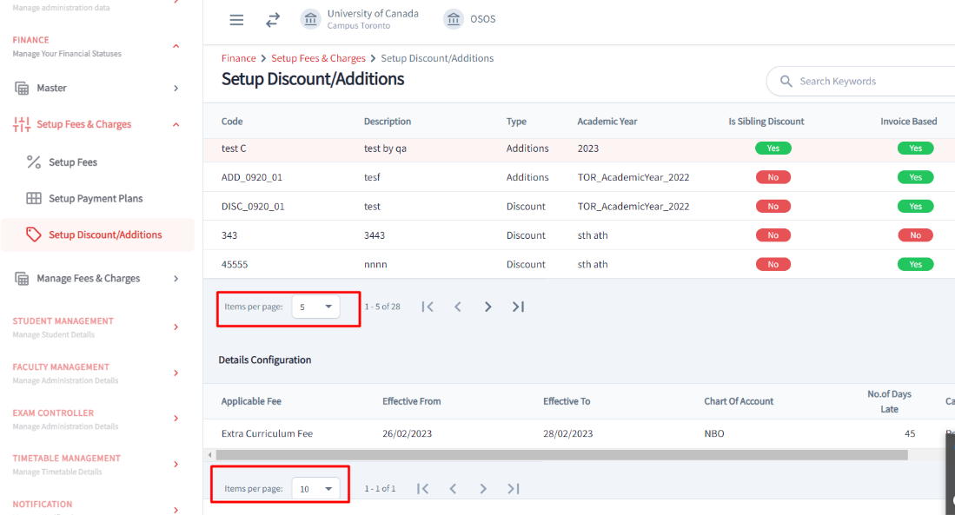
- For all future developments you have to add two new fields to the table when you add a status for an entity. These fields are for update date and update by. When someone changes the status you same time you have to update other two fields as well. Check ApplicationServiceImpl how that has been done. This should be shown below to status in list page table.
Eg. applicationStatus
applicationStatusUpdatedBy, applicationStatusUpdatedAt
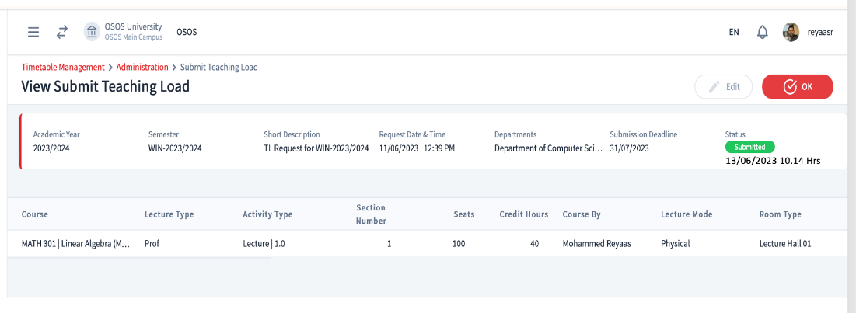
- For new notification service integrations use the function below from notification service.
NotificationService sendNotifications(...)
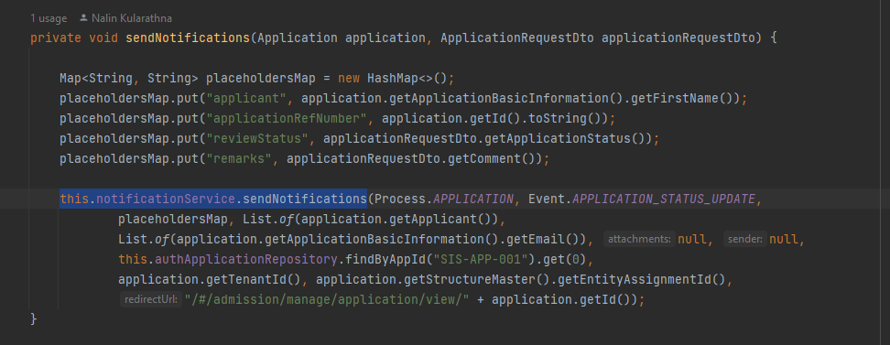
Sample implementation. ApplicationServiceImpl 501 to 514
- All New notification template master
If you create a notification template event you must add default (master) notification template to sis_notification_template_master.
If you added letter template event, then you must add sis_admin_letter_template_master.
Also update the link between notification template and letter template if there is link. Study below file everything is there.
000610-create-notification-template-master-tables.xml

33. System wide Date, Datetime saving
All the dates, datetimes should be saved in GMT0 time. When you retrieve them back and show them on FE you have to convert them based on device time. When you send emails you will have to convert times based on time zone saved on campus.
For BE use: DateUtils.convertTimeBasedCampusTimeZone()
For FE use: DateTimeUtils.convertTimeBasedDeviceTimeZone()

34. Utility Methods: getStartOfDay and getEndOfDay
Use these helper methods to normalize java.util.Date values when filtering records by date range:
- DateUtils.getStartOfDay(Date date)
Returns a new Date with the time set to 00:00:00.000 — useful for "from" date filters.
- DateUtils.getEndOfDay(Date date)
Returns a new Date with the time set to 23:59:59.999 — useful for "to" date filters.
These methods ensure full-day coverage during database filtering (e.g., using >= fromDate and <= toDate).

Authorization Guidelines
1. a module has only one controller we should put as shown below.
Ex. Frontend student
Backend StudentController(@PreAuthorizeGrant(module = ModuleType.STUDENT, permission = PermissionType.CREATE))
Database:- module name:- student, Link:- 'admin/student', code:- STUDENT
2. if a module has more than one controller, we should put same module type for every controller

Ex. Frontend student
Backend ParentStudentController(@PreAuthorizeGrant(module = ModuleType.STUDENT, permission = PermissionType.CREATE))
ChildStudentController(@PreAuthorizeGrant(module = ModuleType.STUDENT, permission = PermissionType.CREATE))
Database:- module name:- student, Link:- 'admin/student', code:- STUDENT
3. if a student wants to access finance API(finance module) from Student module. we should put as shown below.
above finance API @PreAuthorizeGrant(module = {ModuleType.FINANCE, ModuleType.STUDENT}, permission = PermissionType.CREATE)
4 Note:- donot put @PreAuthorizeGrant annotation on List View API

Liquibase Writing
- The Liquibase folder structure has been changed to a new structure shown below.
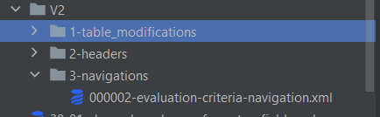
- Both table creations and table modifications go to 1-table_modifications folder.
- Table Insertions also go inside 1-table_modifications folder.
- Don't follow module structure inside those folders.
- Always use the next available number for the Liquibase scripts. The number should contain only 6 digits (Eg:- 000001, 000023, 000546).
  - Eg. For navigation scripts the next available number is 000003.
- Please note that there is no need to define the file anywhere, if you add the file in the correct folder the file will be automatically included for the build.
- Don't add changelog to any file name.
- Follow below folder structure for config service changes.
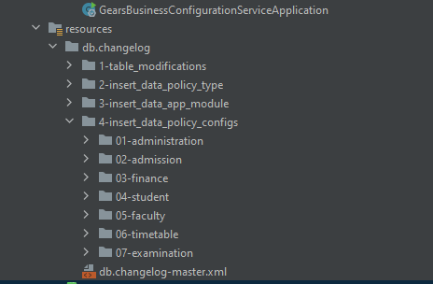

Business Config Service
- How we get policy config value from front end :
Solution:
Front end class name -> PolicyParameterService
Method name -> getPolicyValueByCode
2) How we get policy config value for sis admin backend :
Reference: ApplicationAttachmentServiceImpl.java
Method name : getAttachmentList
Statements =:
BusinessConfigClient businessConfigClient; // This class coming from the business config library
businessConfigClient.readConfig(${policy_code}, ${module}, null, null, null, ${tenant_id}, ${university_assignment_id}, ${campus_assignment_id});

3) Introduced new field for business config service database under the bc_config_template_field table. The purpose of introducing this was due to showing config template field values in proper order on front views. So you have to update sort_order field while you are creating scripts which relate to Template data types policies.
Example:
If you set set_order as 1 then that field shows very first column in FE list view.

4) If policy config is not an active status no need to consider in places where those needs.

Automatic Usage Checking Before Deleting
A common master service development has been done to check foreign key usages of a table before deleting a table row. You may have taken a different approach before to do the same manually using sis_common_entity_map table. In the future, you may not need to manually handle this since this is developed now. This change applies for structure master foreign keys also (therefore both direct id foreign key and structure master foreign key usages are checked before deleting).
However, there could be some special scenarios developers may still have to handle manually such as
- Id is used just as a reference instead of using as a foreign key.
- When creation there could be some places where data is inserted to the child tables at the same time and those child records are useless if parent record is deleted. So, when deleting that parent record, foreign key check is not needed since it is used in the same page instead of a different page that could occur errors. In this case you can override the deleteCheckIgnoredTables() method in the service impl and pass those table names.
Ex:- 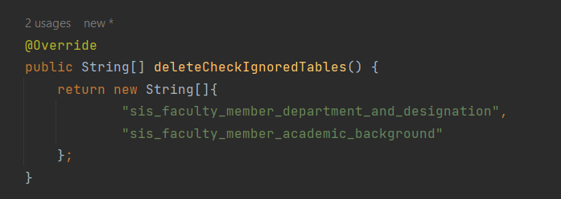

TableReadableName enum
A new enum has been introduced to the system backend named com.ubs.sis.common.domain.enums.TableReadableName. When you create a new page / table make sure to add a value to this enum also. The value should be exactly as the table name. In the enum constructor pass the frontend visible name placeholder as per the placeholder used in the language files. The purpose of this enum is to display a proper meaningful error message in the frontend when a record id deleted from the frontend and when it has usages in other places.
The implementation of this feature is on preDelete method of MasterBaseService. Therefore if your service impl overrides this method, make sure to call the super at first unless you want to ignore this feature.
Example call super:-
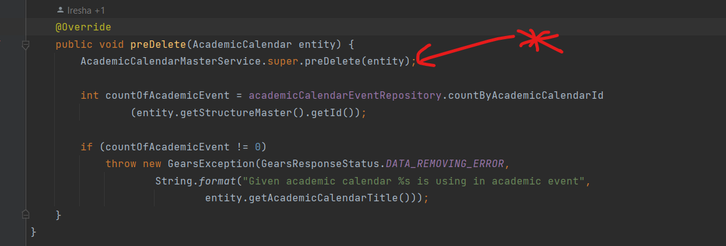
If you service interface is extended by another interface such as BaseService instead of the MasterBaseService you can still implement this feature by overriding the preDelete method in service impl class and calling the MiscUtils.checkUsagesBeforeDelete method at first.
Ex:-
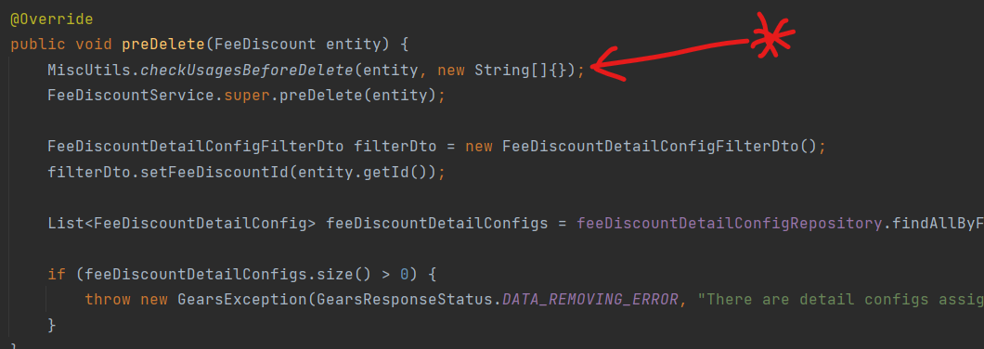

Expandable/Collapsible table common component

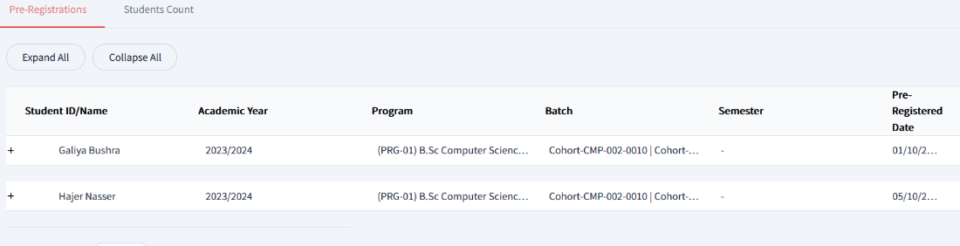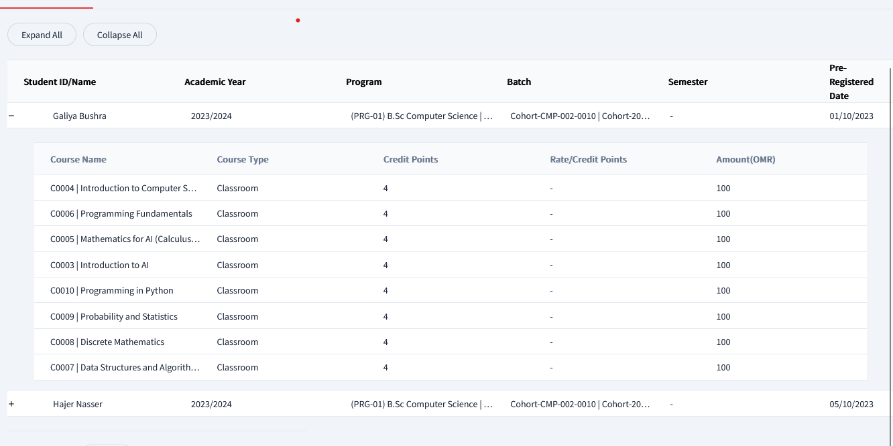

Component path: src/@gears-commons/component/data-table-expandable-collapsable/data-table-expandable-collapsable.component.html
Usage: src/app/modules/student/student-admin/course-pre-reg-offer-submit/course-pre-reg-offer-submit-list-view/course-pre-reg-offer-submit-list-view.component.html
When you create a service in Frontend sis admin service, don't forget to implement all the methods including below method
// This below method is used when enabled expandable and collapsible data table getChildTableContextPath(): string {
return '';
}
Please note that child tables dataset will be coming as the parent table datalist’s expandableCollapsableChildDataList property for each and every parent record if there are child table data.
Also set data for child data table as below:
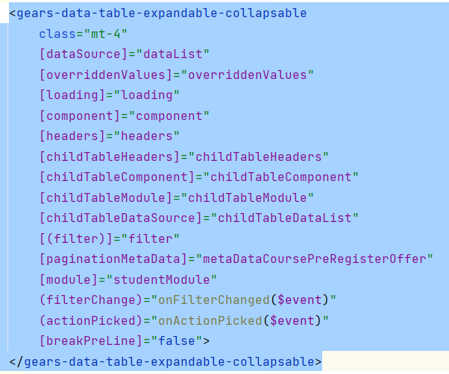

Error handling
- Use translatable error msg in Backend.
Step 1 – Use “GearsResponseStatus.CUSTOM_MESSAGE_ERROR”
Step 2 – Add error message to language file under “error” and add that path as follow
throw new GearsException(GearsResponseStatus.CUSTOM_MESSAGE_ERROR, "admin.error.entityAssignToSomeStyPlans");

Schedular Service important points
- Repository name: https://github.com/pbsgears/sis-scheduler-service
- Needs to use JDK 17 and add into machine environment variables too.
- Uncomment the application.yml file content as below
SCHEDULER_SERVICE_POSTGRES_DB_HOSTNAME: localhost
SCHEDULER_SERVICE_POSTGRES_DB_PORT: 5432
SCHEDULER_SERVICE_POSTGRES_DB_NAME: jan-4-2024 //Your local admin database
SCHEDULER_SERVICE_POSTGRES_DB_USERNAME: postgres
SCHEDULER_SERVICE_POSTGRES_DB_PASSWORD: postgres
ADMIN_SERVICE_BACKEND_URL: http://localhost:8089/api/v1

- If schedular job comes to picture, then you need to add new case statement like below in main class(SisSchedularApplication.java)
switch (args[0]) {
case PUBLISH_ATTENDANCE_SCHEDULER:
publishAttendanceServiceImpl.createAutomaticPublishedOfAttendance();
break;
case COMPLETE_ATTENDANCE_SCHEDULER:
publishAttendanceServiceImpl.completeAttendance();
Case {{new_job}}
Method_call
break;
default:
break;}
- Once you write the logic relates to your new job have to create the new jar by clean and build the spring boot app.
- Goes to Your folder location which created the jar file and open the CMD from there
- Thereafter, executed the below command on CMD terminal
java -jar sis-scheduler-0.0.1-SNAPSHOT.jar {{parameter_name}}

Best practise for logs initialize
- We must use lombok.extern.slf4j.Slf4j to prints the logs in console.
- Class should be annotated with Slf4j annotation at a global level. This should be light weighted and boilerplate codes reduced too.

For Multiline Headers
Common Component: src/@gears-commons/component/header/page-multi-line-header
usage: src/app/modules/admission/manage/application/add-view-edit-application/add-view-edit-application.component.html

Inline Edit Component (Delete-multiple Action)
The showDeleteBulkDialogForRecordList function (Front-end) in the BaseListViewPage.ts file is used to delete multiple records at once in an inline Add/Edit component.
BaseListViewPage.ts
Usage: Please refer below code blocks.
FrontEnd
EvaluationTypeListComponent.html
<sis-admission-page-header pageHeader
[breadcrumbItems]="breadcrumbItems"
(addButtonClicked)="onAddInlineRow()"
[assignButtonVisible]="false"
[filterItems]="filterItems"
[(filter)]="filter"
[component]="component"
[deleteSelectedButtonVisible]="isMultiSelectable && selectedItems?.length > 0"
[saveAllButtonVisible]="isVisibleSaveAllButton"
[editAllButtonVisible]="isVisibleEditAllButton && dataList?.length > 0"
(saveAllButtonClicked)="saveAll()"
(editAllButtonClicked)="editAll()"
(deleteSelectedButtonClicked)="deleteSelectedItems()"
(filterChange)="onFilterChanged($event)"></sis-admission-page-header>

EvaluationTypeListComponent.ts
deleteSelectedItems(): void {
if (!PreAuthorizeGrantService.checkPermission(this._router.url,'DELETE')) {
this._gearsAlertService.showErrorAlert(translate('message.common.permissionDenied'));
return;
}
if (this.selectedItems && this.selectedItems.length > 0) {
const selectedNewRows = this.selectedItems.filter(item => item.id === null);
const selectedRows = this.selectedItems.filter(item => item.id !== null);
if (selectedNewRows?.length > 0) {
selectedNewRows?.forEach(item => {
if (item?.id === null) {
const index = this.dataList.indexOf(item);
if (index !== -1) {
this.dataList.splice(index, 1);
this.dataList = this.dataList
.map(data => data);
}
}
});
}
this.selectedItems = this.selectedItems.filter(item => item && item.id !== null);
if (selectedRows?.length > 0) {
this.showDeleteBulkDialogForRecordList(this.selectedItems);
}
this.setVisibleEditSaveAllButton();
}
}

Backend
EvaluationTypeController.java
@PreAuthorizeGrant(module = {ModuleType.EVALUATION_CRITERIA, ModuleType.EVALUATION_TYPE}, permission = PermissionType.DELETE)
@DeleteMapping(value = "/bulk")
public Response<DeleteResponseDto> deleteBulk( @RequestBody List<Long> idList) {
return evaluationTypeService.deleteBulk(idList);
}

EvaluationTypeServiceImpl
@Override
public Response<DeleteResponseDto> deleteBulk(List<Long> requestDtoIdList) {
Response<DeleteResponseDto> response = Response.ok();
if (!requestDtoIdList.isEmpty()) {
List<EvaluationType> evaluationTypes = evaluationTypeRepository.findAllByIdIn(requestDtoIdList);
if (!evaluationTypes.isEmpty()) {
evaluationTypes.forEach(evaluationType-> {
this.preDelete(evaluationType);
});
evaluationTypeRepository.softDeleteAllInBatch(requestDtoIdList);
}
}
return response;
}

EvaluationTypeRepository.java
public interface EvaluationTypeRepository extends BaseRepository<EvaluationType> {
List<EvaluationType> findAllByIdIn(@Param("idList") List<Long> idList);
@Modifying
@Transactional
@Query("UPDATE EvaluationType e SET e.deleted = true WHERE e.id IN :ids")
void softDeleteAllInBatch(@Param("ids") List<Long> ids);
}

Inline Edit Component (Save-All Action)
Ticket: GSIS-7235 - Refer the comment section in this ticket.
To save multiple records at once in inline add/edit components, use the saveBulk() function in base-crud-service.ts file.
base-crud-service.ts
In your custom component, implement the saveBulk() function as part of the 'Save All' button’s click handler to commit multiple inline records at once.
Frontend
evaluation-type-list.component.ts
saveAll(): void {
let isValidated = true;
const modifiedList: EvaluationTypeMaster[] = this.rows.map(item => {
if (!this.validateInlineRowBeforeSave(item)) {
isValidated = false;
}
item.tenantId = TenantService.getSelectedTenantId();
item.activeStatus = item.activeStatus ? item.activeStatus : false;
item.contextAssignmentId = this.contextMenuService.getSelectedChildId();
return item;
});
if (!isValidated) {
return;
} else {
this.evaluationTypeMasterService.saveBulk(modifiedList).subscribe({
next: response => {
this._gearsAlertService.showSaveSuccessAlert(this.getComponent());
this.dataList = response?.payload;
this.setVisibleEditSaveAllButton();
this.loadData();
}, error: error => {
if (error !== undefined && error.error !== undefined && error.error.statusCode === 4000) {
const errorMessage = (error.error.errors !== undefined && error.error.errors.fieldErrors !== undefined
&& error.error.errors.fieldErrors.length > 0)
? error.error.errors.fieldErrors[0].message
: this.getComponent();
this._gearsAlertService.showErrorAlert(errorMessage);
} else {
this._gearsAlertService.showErrorAlert(translate(error.error.message));
}
}
});
}
}

Backend
EvaluationTypeController.java
@PreAuthorizeGrant(module = {ModuleType.EVALUATION_CRITERIA, ModuleType.EVALUATION_TYPE}, permission = PermissionType.CREATE)
@PostMapping(value = "/bulk")
public Response<List<EvaluationTypeResponseDto>> createBulk(
@RequestBody @Valid List<EvaluationTypeRequestDto> requestDtoList) {
log.info("EvaluationTypeController::createBulk - {}", requestDtoList);
return evaluationTypeService.createBulk(requestDtoList);
}

EvaluationTypeService.java
Response<List<EvaluationTypeResponseDto>> createBulk(List<EvaluationTypeRequestDto> requestDtoList);

EvaluationTypeServiceImpl.java
@Override
public Response<List<EvaluationTypeResponseDto>> createBulk(List<EvaluationTypeRequestDto> requestDtoList) {
Response<List<EvaluationTypeResponseDto>> response = Response.ok();
List<EvaluationTypeResponseDto> evaluationTypeResponseDtos = new ArrayList<>();
if (!requestDtoList.isEmpty()) {
List<EvaluationType> evaluationTypes = new ArrayList<>();
evaluationTypes = requestDtoList.stream()
.map(evaluationTypeRequestDto -> {
if (evaluationTypeRequestDto.getId() != null)
return validateAndMapToEntityForUpdate(evaluationTypeRequestDto, getEntityById(evaluationTypeRequestDto.getId()));
else
return validateAndMapToEntityForSave(evaluationTypeRequestDto);
}
).collect(Collectors.toList());
evaluationTypes = evaluationTypeRepository.saveAll(evaluationTypes);
this.postSaveAll(evaluationTypes, requestDtoList.get(0));
evaluationTypeResponseDtos = evaluationTypeMapper.mapEntityListToResponseDtoList(evaluationTypes);
}
response.setPayload(evaluationTypeResponseDtos);
return response;
}

Feature Documentation: MiscUtils.getEntityUsages

Overview
The getEntityUsages utility method provides a centralized way to retrieve all the references (usages) of a given entity across the database. This is particularly useful for validating operations such as update or delete, ensuring that an entity is not referenced by child records in other tables.

Parameters
Parameter | Type | Description
entity | BaseEntity | The entity instance for which usages need to be checked.
checkIgnoredTables | String[] | Optional array of table names to be ignored during usage checks (e.g., temporary or unrelated tables).

Returns
Return Type | Description
List<String> | A list of readable placeholders representing all tables or references where the entity is currently used. If the entity is not referenced anywhere, an empty list is returned.

Example Usage – Update Scenario
The getEntityUsages() method is used during update operations to ensure that an entity is not referenced by other records in the system.
If the entity is in use, a GearsException should be thrown with either error metadata or the list of used places.

@Override
public void preUpdateEntity(SomeEntity entity, SomeEntityRequestDto requestDto) {
List<String> usedInPlaces = MiscUtils.getEntityUsages(entity, new String[]{
"table_to_ignore_1",
"table_to_ignore_2"
});
if (!usedInPlaces.isEmpty()) {
HashMap<String, Object> errorMetaData = new HashMap<>();
errorMetaData.put("usedInPlaces", usedInPlaces);
throw new GearsException(
GearsResponseStatus.RECORD_IN_USE_ERROR,
"message.common.alreadyInUseErrorUpdate",
errorMetaData
);
// or
// throw new GearsException(
// GearsResponseStatus.RECORD_IN_USE_ERROR,
// "Already assigned to child components",
// usedInPlaces
// );
}
}

Explanation
- MiscUtils.getEntityUsages(...) identifies where the entity is referenced in other tables.
- usedInPlaces contains a list of modules or tables referencing the entity.
- Option 1 (errorMetaData) is preferred for structured frontend handling.
- Option 2 (usedInPlaces) is simpler for quick validation.
- GearsResponseStatus.RECORD_IN_USE_ERROR ensures a unified backend-frontend error flow.

Frontend Integration
On the Angular side, this error is handled centrally through the GearsAlertService.
When an exception with the status RECORD_IN_USE_ERROR is received, the alert service automatically displays a descriptive, translatable message.
} else if (errorCode === Response.RECORD_IN_USE_ERROR) {
if (!errorMetaData?.usedInPlaces) {
this.showDeleteErrorAlert(translate('message.common.alreadyInUseError', {
usedPlaces: usedInPlaces.map(element => translate(element)).join(', ')
}));
} else {
this.showDeleteErrorAlert(translate('message.common.alreadyInUseErrorUpdate', {
usedPlaces: errorMetaData?.usedInPlaces?.map(element => translate(element)).join(', ')
}));
}
}

Frontend Update Error Handling Example
For update operations, you can handle RECORD_IN_USE_ERROR in your component’s error callback:
onDataUpdateError(error: any): void {
if (error.error.statusCode === Response.RECORD_IN_USE_ERROR) {
this._gearsAlertService.onError(error, this.getComponent(), false);
this.goBack(); // Optional: navigate back or handle accordingly
} else {
super.onDataUpdateError(error);
}
}

